www.NarcForce.com

Search Warrant and Major Case Investigation
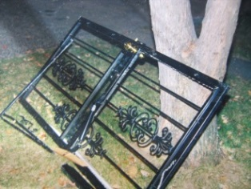
Seminar

June 8-9, 2017

Instructor: Lt. Colonel Mike Halbleib
Narc Force 502-442-3295

Attendees: Uniform Officers / Detectives / Commanding Officers

Limited Seating: 25

Time: 9:00 am – 5:00 pm ( Eastern Time Zone )

Location: Eminence Police Department
1363 Elm Street
Eminence, Kentucky 40019

Hotel: NA

Registration Fee: $295 (Includes seminar training materials)
Call 502-442-3295 or Visit Narcforce.com to register

Instructor
Mike Halbleib is currently a Captain with the Bullitt County Sheriff’s Office Drug Task Force. Mike began his career with the Louisville Police Department in 1992 and retired in 2013. He was promoted to Detective with the Metro Narcotics Major Case Unit. Mike investigated numerous major case narcotic trafficking organizations and assisted in the prosecution and conviction of several criminal syndicates / conspiracies. He was awarded the Louisville Police Officer of the year in 2000 while in the major case narcotics unit. Mike was a Field Training Officer for 6 years. He also spent 5 years in Homicide and 4 years on SWAT. Mike is certified with the Kentucky Law Enforcement Council and has been teaching in the field of narcotics for the community, police in-service classes and recruit classes for 16 years.

Mike was also awarded the Executive Merit Award, the Jefferson County Judge Executive’s Merit Award and nominated for the 2009 & 2010 Bluecoat’s Officer of the Year. Currently Mike is a Captain and operating a drug task force that focuses on mid level and major case cartel investigations. He is currently an expert witness for the Jefferson County Commonwealth Attorney’s Office.

